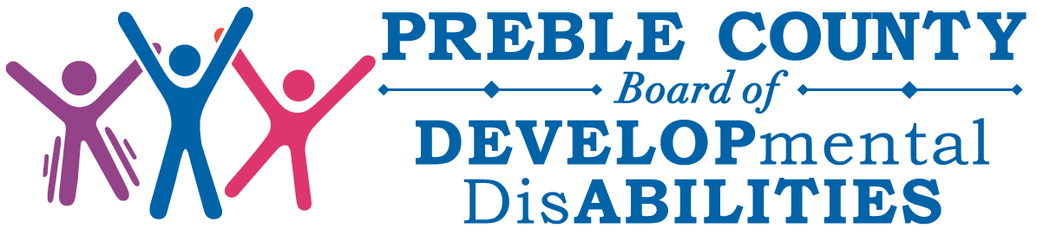
PREBLE COUNTY BOARD OF DEVELOPMENTAL DISABILITIES
Thursday, April 15, 2021
VIRTUAL/ IN PERSON MEETING
6:00pm

AGENDA
- Call to Order

- Roll Call

- Approval of Board Member Absence

- Pledge of Allegiance

- Reading of the Vision and Mission Statement

- The VISION of the Preble County Board of DD is to provide the best possible
opportunity for individuals with developmental disabilities to have the kind and quality of life he or she chooses.

- The MISSION of the Preble County Board of DD is to support individuals with developmental disabilities to live, learn, work, and socialize as they choose.

- Introduction of Guests

- Approval and Note Receipt of Minutes
- March 2021 Regular Board Meeting Minutes

- Financial Report
- March 2021 Board Financial Statement

- Board Committees
  - Personnel and Finance Committee Report
  - Approval of Personnel and Finance Committee Meeting Minutes

- Superintendent Report

- Hearing of the Public

- Executive Session according to ORC 121.22 G1:
  - to consider the employment and compensation of a public employee.

- Adjournment
Next Board Meeting – May 20, 2021 @ 6:00 p.m.

